**USB interfaces**

The input to the hub will be a type USB 3.2 Gen 2 type C with capabilities up to 10 Gbps

This will handle up to

* 1x M.2(SATA +Nvme)
* 1x USB 3.2 Gen2 type C
* 2x USB 3.2 gen1 type A
* 1x SD card UHS II 250MB/s
* 1x micro-SD card
* 1x 3.5mm headphone Jack
* 1x 100W PD Type C input (charging)
* 1x RJ45 1 Gbps
* 1x HDMI 2.0
* 1x type C connect to Ipad

The design will be divided into sections i.e.

1. **USB HUB DESIGN -**this will encompass the design of a USB HUB from the host PC; upward facing port (UFP) or controller to the downward facing ports(DFP).

The section will handle the design of –

* 1x USB 3.2 Gen2 type C - from the hub controller
* 2x USB 3.2 gen1 type A - from the hub controller
* 1x micro-SD- card via integrated HUB IC bridge for SPI
* 1x type C connect to Ipad – via a basic type C with low-medium speed capabilities (not high speed) this will be directly from the DP and DM of the USB C which will be free.
* 1x SD card UHS II 250MB/s – This will be interfaced to the HUB controller via a USB – SD CARD controller. Recommended: **MAX14502. other MA8121K** (unavailable mostly),

**Features of MAX14502:** support up to 480Mbps operation via USB.

Available only at mouser at $14.8

Highly integrated reducing BOM

* 1x RJ45 1 Gbps – the connection of this port will be via a USB to Lan/Ethernet controller Recommended: LAN7850 (Ref: <https://www.microchip.com/en-us/development-tool/EVB-LAN7850> ) the USB-HUB controller will then drive and control the ethernet via the USB HUB.
* M.2 controller for NVME and SATA – We need a M.2 to USB controller/interfacing IC – (yet to be establish the appropriate controller).

**the controller that could be used is PI7C9X442SL or PI7C9X440SL**(only available at mouser)

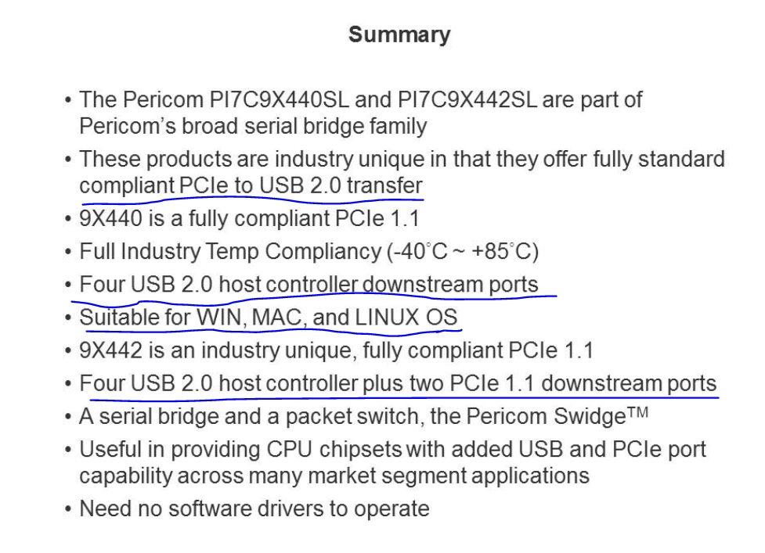

That makes the total number of DFP (downward facing ports) equal to SIX (6).

Plus, SPI for micro - SD card bridging and I2S for may be considered for audio bridging.

The recommended HUB CONTROLLER that fits this is the **USB7206 from microchip.**

* It has 6 down facing ports which will handle the various protocols

**FOR THE MULTIPLEXER TO HANDLE DATA FLOW FROM THE INPUT TO THE OUTPUT AND HAS DISPLAY PORT ALTERNATE MODE**

Recommended: **HD3SS460** and a *display port to HDMI converter (i.e., MCDP2900) and a HDMI connector.*

Note: The PD Controller is controlled by the HD3SS460 which then negotiates power for the display.

The HD3SS460 will as well handle audio via AUX output to be connected to the audio Jack.

The **HD3SS460** also feeds the USB HUB controller via the RX and TX pins

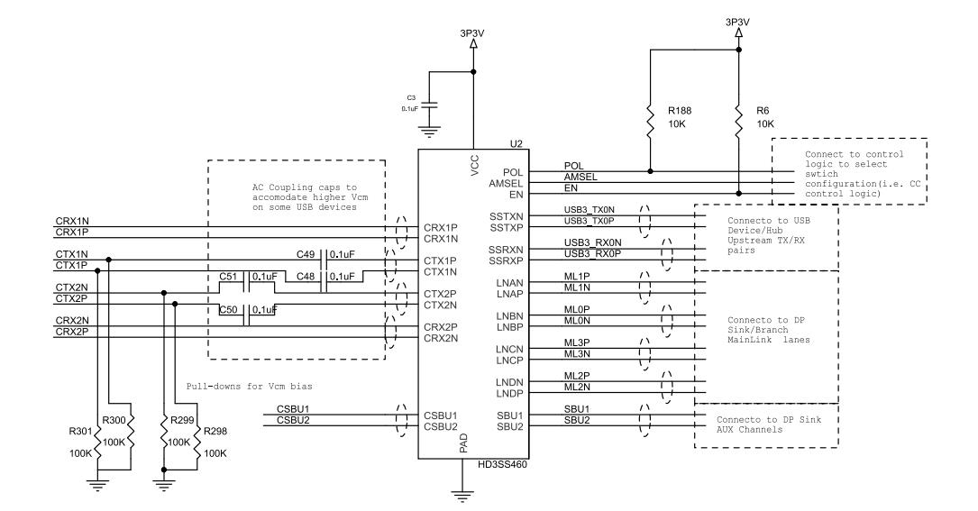

In design of schematic, ensure differential pair designing considerations.

**SECTION 2: POWER DESIGN FOR THE HUB**

This is the 100W power input via USB C input.

* This will be controlled via a PD controller that will negotiate the power requirements accordingly and power the whole hub when connected. The PD controller of choice is **TPS6598X** i.e., **TPS65982(we will the certified PD controller such as TPS65987)** from Texas instruments that features an integrated PD controller and an internal highspeed communication and I2C interfacing. It can handle up to 100W via external mosfet and up to 3A at 20V with internal MOSFET.
* Battery charging IC will be via a Buck Boost charging IC with the configuration as shown below.

The charger can be a BQ25731 buck-boost charger that can support up to 100W charging via the help of external mosfets.

* 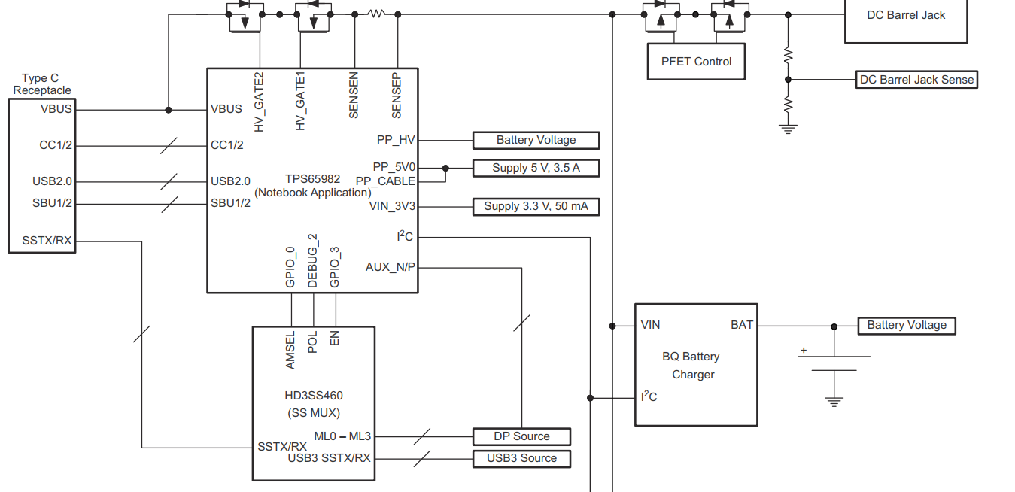
* The lower voltages needed for the running of the USB HUB and the Multiplexer will be supplied via a 5V LDO, 3V3 LDO, 1V5 LDO and 1V2 LDO as per the datasheet of each part.

NOTE// **CORRECTION:** The 5V regulator need changes to a buck regulator that is able to supply over 3-6 A of current for use with 1.2V powered systems and supply for each DFP port. 3.3V can be a linear regulator.

**SECTION 3: PROTECTION OF EACH AND EVERY SECTION**

1. Input VBUS short circuit protection
2. Electrostatic protection via TVS diodes
3. Over current protection – prevent output ports from drawing too much current

The current consideration for the USB connectors should be about 500mA to 1A.

**Ensuring:** proper Bulk decoupling of every voltage source and decupling capacitors on each IC.

In rush current is not too high due to the number of capacitors in use.

Low EMI design.

Impedance matching and proper trace widths for current propagation.

**FINAL DESIGN**

